Shena Massey, lab9

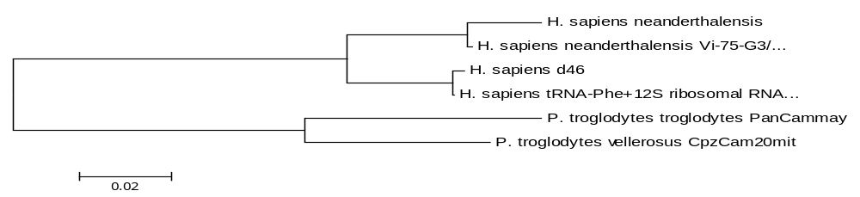

Figure 1: mtDNA.MEG, using non-coding DNA sequences (unequal branches- neighbor join)

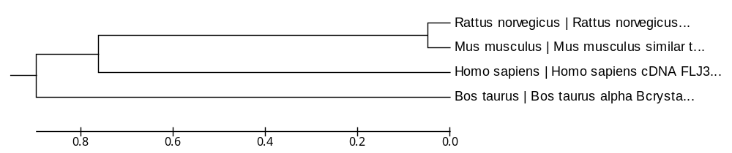

Figure 2: Tree using protein-coding DNA sequences, “s: synonymous only” UPGMA- equal distance

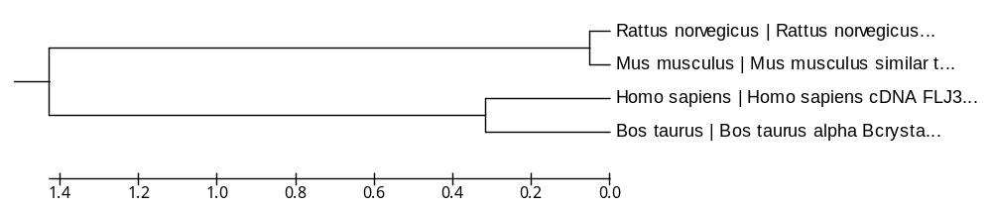

Figure 3: Tree using protein-coding DNA sequences “ n: nonsynonymous only” UPGMA- equal distance

